Method Selection and Planning

Software Engineering Methods and Collaboration Tools

The software engineering methodology that we chose was Scrum. Scrum is an agile methodology allowing smaller teams to work efficiently to strict deadlines. This means that the focus is on iterating smaller sections of the whole project rather than trying to build the entire thing in one go. The advantage of this is that any short notice requirement changes are easier to deal with and so means the team is more flexible. We will use discord as our communication platform for our scrum meetings which we will hold regularly**.** In these meetings each member takes a couple minutes to explain what they are doing on the day and how other members tasks may coincide with their own. Discord is the obvious choice for our team as we live all over York, we can communicate verbally at any time and this allows explanations of ideas to take much less time than text-based messaging. Further to this we will use Trello to track tasks, whether that be tasks to do, tasks in progress, or completed tasks, see example below.

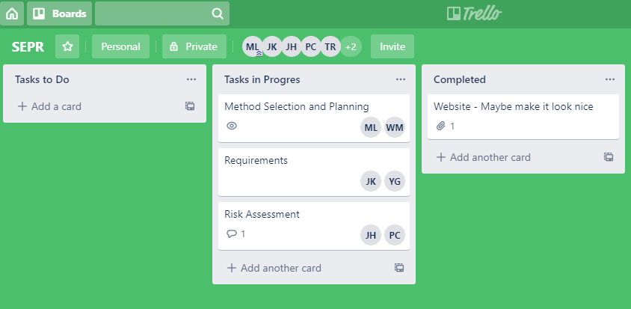

Trello allows us to comment and assign members to each task allowing us to see at a glance what needs doing and who could potentially do it. This meshes well with the agile methodology as it allows tasks to be quickly edited and swapped out. We will also not hesitate to contact the customer if any design issue or ambiguity arises, this is another core feature of an agile methodology as embedding the customer in the team allows us to better understand their needs.

We chose against classical and plan driven methods as these wouldn’t allow us the flexibility of being able to change requirements. One such classical methodology is the Waterfall model, this is a very linear model where all requirements are drawn up first, then the software architecture is designed and then all the software is implemented. This linear model does not offer much scope for change and as such does not suit our project as we anticipate change to the requirements that exceeds 1% change per month. Further to this, plan driven methods focus heavily on documentation and so tend to weigh the project down with unnecessary bureaucracy. This may well work for scenarios such as the client being remote, or where extensive documentation would be needed upon release anyway, but we thought that neither of these apply to this project. See below the figure on the waterfall methodology.

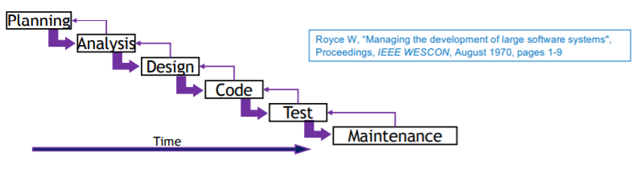

Due to the structure of the project we will roughly follow the RUP (Rational Unified Process) anyway but we aim to have smaller gaps between each stage. For example, as I am writing this the requirements are also being written up which is one of the first parts of the project that would be heavily focused by RUP. We will, as a part of this, attempt to construct stories to help us anticipate potential issues that may arise in the future. For example we could construct one of the typical user to figure out what features we need to make the product as intuitive as possible.

On top of Discord and Trello we will also use GitHub, this is the obvious choice for any software development project as it allows easy collaboration and has many 3rd party applications that can push/pull etc. This means each team member can use their favourite application and it will have no adverse effect on the other members of the team.Git hub allows for easy collaboration between a group as code can be written over multiple branches and these branches can then be merged to the main deliverable branch when all code is working. GitHub also allows for rollback to older versions meaning that if a commit breaks the whole program then the software can be rolled back to the previous version while the initial problem is fixed.

Further to this we are and will use google drive for all writing based tasks in this assessment. Google drive is excellent for collaborating on documents as it allows multiple people to edit the same document in real time. This means that writing tasks can be done much quicker and there is no need for merging like we would need to do if we did the same thing using GitHub.

As we are coding this project in Java we are following an object oriented design, this has many benefits for our team. Firstly, the code is much easier to compartmentalise, we can get each member to write specific classes given a specification and they should all mesh together in the final product. Secondly, object-oriented design allows us to abstract out key design features into objects, for example a fire engine is its own object with its own methods and attributes, and this makes designing the overall product more manageable and more easily translatable to code. Further to this we can use inheritance to reduce the file size of the game and make designing certain aspects easier. Following our fire engine example, this object could inherit from a class called “moveable” which is an item in the game capable of moving and therefore we only need to write the “moving” code once.

In order to design and prototype the architecture we are going to use UML (Unified Modeling Language). This will allow us to graphically represent all of the classes and the relationships between them enabling us to refine the architecture well enough for us to implement. It will also enable us to bring this visual representation of our architecture to meetings with the client if they so wish. Further to this a visual representation of our system will be easier to understand than a written one meaning we spend less time re-reading documentation and more time designing and implementing. To design this we researched a number of different programs to achieve an effective UML diagram. Initially we looked at PlantUml which allows a textual representation of the UML diagram. This automatically creates the links between classes ensuring the correct formatting of the finished diagram. However, we decided against this method over an online GUI based program called LucidChart. This allows multiple members to collaborate in real time to design a UML diagram with the main disadvantage being that is does not force the correct syntax meaning that we had to be careful to ensure that the correct arrows were used in order to make it easier to follow in the implementation stages of the project. We decided that this tradeoff was worth it due to multiple people needing to work together on the diagram remotely which would greatly decrease the time needed to complete it.

Team Organisation

The first thing that we decided was to not have any one distinct leader. This is important as it allows us to all speak up and feel like we have equal contribution towards the project meaning, that we don’t quell anyones ideas. Utilising each team member to their fullest potential is important as it is the most efficient way of running a team in our view. Therefore we delegated tasks based upon who prefers doing what and who thinks they will be best at particular things. This will result in each person putting their whole effort into each task as they don’t feel they have been forced into doing an area of the project they aren’t comfortable with. Obviously there is some degree of flexibility when it comes to a plan such as this as we will not always be able to delegate tasks in this way. There may be a time where one person doesn’t feel fully comfortable doing any task and this will be dealt with by them doing their most preferred option. This should lead to a higher quality final product as all work done on it would have been done to its best ability. Another exception to this would be difficult/longer tasks. In either case we will need a lot more development time behind these, resulting in a large portion of the group being pulled in to complete it. This is better than the alternative of bringing more people on board of a subproject that is already behind schedule, as this will likely push the project further behind due to the fact that new people will need to be brought up to speed with the delayed subproject.

Once each subproject is completed each team member will be reassigned to a new task in order to aid with it. It is up to the individual in this case to bring themselves up to speed as quickly as possible so as not to run into the same issue as before. The individual in question should aim to disrupt the current developers working on that task as little as possible by catching up through non verbal forms first (reading docstrings etc) and asking questions only when necessary. For each task there will be a rough plan of what has been done and what is to be done (classes and methods that need to be built for example). This should help us overcome the problem stated above in the previous paragraph.

When we initially plan out the subtasks for each given section we will deliberately make our internal deadlines early. This will give us some breathing room in the event that we come across any unanticipated blockers. Some people may see this as a pointless endeavor, why make a plan if you aren’t going to follow it? We see it as a guideline for our own internal schedule as we are aware that in the real world, plans change and so we need to be ready to anticipate that. This meshes well with the project as a whole as we anticipate change and therefore making rigid plans without any flexibility wouldn’t be a smart idea.

We will aim to have a transparent working environment. This means that each member is clear about what sections they are working on, how their progress on that section is going, and if any issues have arisen that are difficult to overcome. Trello has helped to manage this by enabling us to see what tasks are in progress at a glance and see who is doing what. It is therefore important that each team member keeps this updated as otherwise the tool is useless. A large portion of transparency is frequent communication. Meetings are and will be held regularly over discord and quick questions can be asked at any time of day via our group chat. Discord meetings are a good form of communication as we can all communicate verbally which enables us to get ideas across much faster than we would via a text based communication service. It is important however, that we don’t forget about our group chat. This is a much easier way of communicating, without requiring a scheduled meeting where everyone must be free to talk (questions can be asked and answered while on public transport for example).

In conclusion these approaches ensure that each team member has an equal say and are placed where they will perform best. The tasks with the highest priority will be completed first to ensure that tasks with dependencies aren’t delayed and that the core features will be implemented. Reassignment to tasks that are taking time will prevent bottlenecks in development. It is the responsibility of individual team members to catch up on reassigned tasks. Internal Deadlines will be stricter than actual to enable agile development and all team work is to be transparent to give the team as a whole a better understanding of the progress of the overall project.

Assessment 2: Preliminary Implementation, due: noon, Spr/3/Mon

For assessment 2 the initial tasks will be to implement the classes proposed in architecture. This will be split into several task groups: the fire engines and fires stations; the ETs and fortresses; the map and coordinate systems. These will then be beneficial to then develop the process of the game, though assuring the map functions correctly will take priority as this is the most critical task here as any features for fire engines or ETs specifically can have placeholders used. Alongside the programming, some graphical designs would be beneficial, but a functioning game is the highest priority.  
  
Testing may include changes to code so some written documents will be produced following the testing process. Written documents will include an implementation report, a testing report, a report on architecture, a user manual and updates to previous documents. We will spend multiple days reviewing final reports and attacking final issues.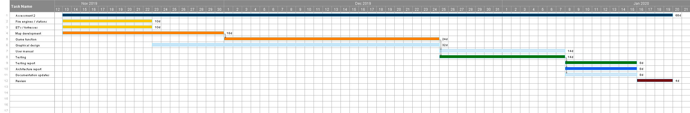

Assessment 3: Selection, Extension and Integration, due: 17/02/20

The first phase of assessment 3 will be the evaluation and selection of project to develop further with known requirements. The ideal priority of evaluation should be around the ease of implementing the further features, with other focuses being completeness of the project, documentation quality and the overall standard. This process will occur between 20/01/20 - 27/01/20, during which we will also be doing a presentation.

During the second phase of extending the project to include all the requirements, the features that will need to be added are: two or more fire engines, three or more fortresses, the minigame, patrols, scaling fortress strength and possible destruction of fire stations. Furthermore, any incomplete requirements from assessment 2 will need to be completed first, which should take priority as there will be dependencies. The minigame will be delegated to a small group and other features will be individual. A change report will document any necessary alterations to the base project.

Assessment 4: Selection, Requirements Change, due: 29/04/20

In a first phase of assessment 4 we will be evaluating and deciding on a project to alter. The changes made to this project will be unknown in this phase, so the project chosen should be easily adaptable. Alongside adaptability, overall quality, documentation and adherence to the current brief. This process will occur between 17/02/20 - 24/02/20, and we will present our project to other groups at this point.

For the second phase where we will be implementing features to satisfy new requirements, the requirements will need to be reviewed at the time. In doing this we will be able to form a strong development plan. A presentation to a client will be devised following the deadline to be presented on 17/05/20.